Project Development Phase
Model Performance Test

Date | 28 September 2026
Team ID | 6ab2210011b716a3e52c62c6
Project Name | Streamlining IT Procurement: Automating Standard Laptop Orders with Flow Designer
Maximum Marks | 10 Marks

Model Performance Testing:
Project team shall fill the following information in model performance testing template.
S.No. | Parameter | Values | Screenshot
1. | Model Summary | ServiceNow automation setup for standard laptop procurement using Flow Designer and Service Catalog.  Note: Once the request is approved, the flow automatically creates a Catalog Task with short description "Laptop needs to Configured" and assigns it to the Hardware group. | 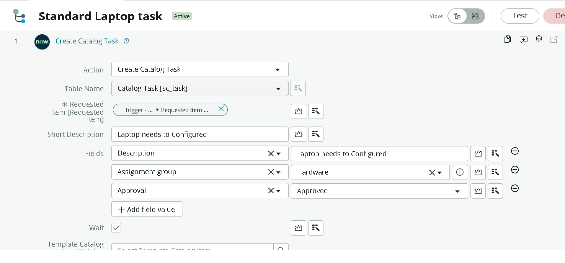
2. | Accuracy | Training Accuracy - 100%  Validation Accuracy - 100%  (Test order was approved and the Catalog Task was created correctly.) | 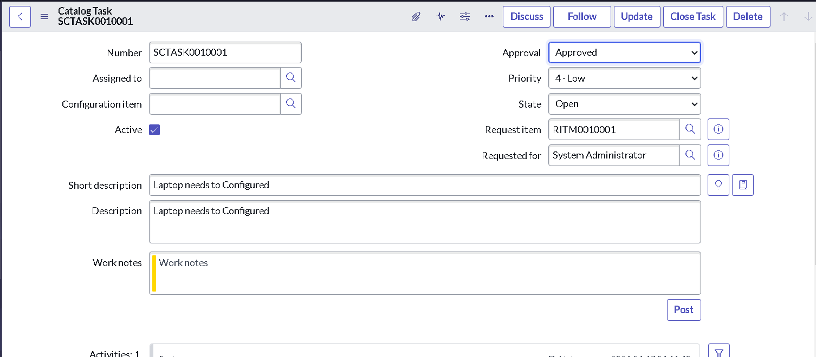
3. | Confidence Score (Only Yolo Projects) | Class Detected - Not applicable  Confidence Score - Not applicable  This is not a YOLO project. | -

